Phase 3 Report

DO project

Group 2

Introduction:

In today's fast-paced world, where demands on our time seem to be ever-increasing, staying on top of our tasks and maximizing productivity can often feel like an insurmountable challenge. However, in this digital age, technology offers us the opportunity to not only manage our daily responsibilities efficiently but also elevate our overall productivity.

Enter "Do," your all-in-one web application designed to transform the way you organize tasks and supercharge your productivity. "Do" is a user-friendly tool created to monitor your workflow, helping you achieve more in less time while reducing stress and overwhelm. This groundbreaking web app combines innovative features and simple design to help you regain control of your schedule and turn your aspirations into accomplishments.

From task management and prioritization to insightful data analytics, "Do" is your personal productivity assistant. Join us as we explore how "Do" empowers you to reach new heights in productivity, simplify your daily life, and ultimately accomplish more than you ever thought possible. Discover a better way to get things done with "Do."

Users of the app:

It is developed for individuals and people who work in teams.

Actors :

User , project manager

Schedule:

FALEH AL-KHALDI : front-end , back-end

MOHAMMED ALGHUNAIM : front-end , back-end

MOHAMMED ALJAAFARI : front-end , back-end

MOHAMMED ALJOUDI : front-end , back-end

MOHAMMED ALOTHMAN: front-end , back-end

Requirements Modeling:

A:

1-User should be able to add tasks

2- User should be able to create a project.

3 – User should be able to add people to a team

4 – User should be able to assign tasks to his team members (Only the leader can do this)

5 – Users can finish a task by clicking check on it

6 – user can visualize his progress

7 – User can schedule a task

B:

1 – Usability

2 – Integrity

3 – Testability

4 – Reusability

5 – Maintainability

C:

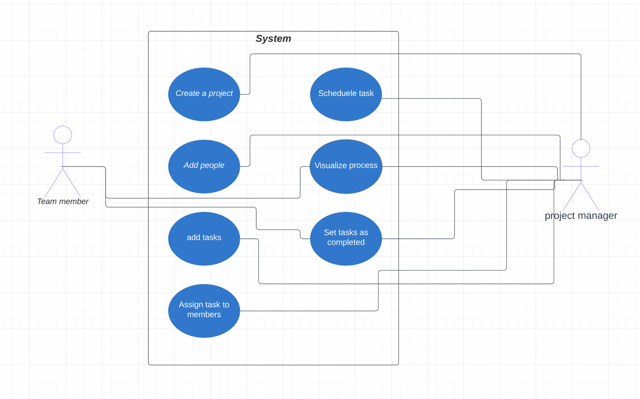

D:

|  |  |  |  |
| --- | --- | --- | --- |
| **Use case ID:** | 1.1 | | |
| **Use Case Name:** | Create a project | | |
| **Created by:** |  | **Last Updated by:** | Mohammed aljaafari |
| **Date Created:** | 29/03/2023 | **Last Revision Date:** |  |
| **Actors:** | Project manger | | |
| **Description:** | A project is where a set of related tasks are in | | |
| **Trigger:** | Click | | |
| **Preconditions:** | * User has to be signed in | | |
| **Postconditions:** | * A project should be appended to the previous projects of the user(if any) | | |
| **Normal Flow:** | * User logs in * Clicks on create project in home screen | | |
| **Alternative Flows:** | * User logs in * Goes to projects section * Click add new project | | |
| **Exceptions:** | Non | | |
| **Assumptions:** |  | | |
| **Notes and Issues:** |  | | |

|  |  |  |  |
| --- | --- | --- | --- |
| **Use case ID:** | 1.2 | | |
| **Use Case Name:** | Schedule a task | | |
| **Created by:** |  | **Last Updated by:** | Mohammed aljaafari |
| **Date Created:** | 29/03/2023 | **Last Revision Date:** |  |
| **Actors:** | user | | |
| **Description:** | Setting a deadline or due date for a task | | |
| **Trigger:** | click | | |
| **Preconditions:** | * A user has to be signed in and a real task should be selected | | |
| **Postconditions:** | * A task should have a deadline appeared on it | | |
| **Normal Flow:** | * When adding a task user selects the option schedule * Put the date | | |
| **Alternative Flows:** | Non | | |
| **Exceptions:** | Non | | |
| **Assumptions:** |  | | |
| **Notes and Issues:** |  | | |

|  |  |  |  |
| --- | --- | --- | --- |
| **Use case ID:** | 1.3 | | |
| **Use Case Name:** | Add people | | |
| **Created by:** |  | **Last Updated by:** | Mohammed aljaafari |
| **Date Created:** | 29/03/2023 | **Last Revision Date:** |  |
| **Actors:** | Project manger | | |
| **Description:** | Adding collaborators to the project. | | |
| **Trigger:** | click | | |
| **Preconditions:** | * A user has to be signed in and a real project should be selected(members<=5) | | |
| **Postconditions:** | * The project should appear in the collaborator screen and be able to access it | | |
| **Normal Flow:** | * User enters the project * Select add members * Choose the member * Click add | | |
| **Alternative Flows:** | non | | |
| **Exceptions:** | Members should be less than 5. | | |
| **Assumptions:** |  | | |
| **Notes and Issues:** |  | | |

|  |  |  |  |
| --- | --- | --- | --- |
| **Use case ID:** | 1.4 | | |
| **Use Case Name:** | Add tasks | | |
| **Created by:** |  | **Last Updated by:** | Mohammed aljaafari |
| **Date Created:** | 29/03/2023 | **Last Revision Date:** |  |
| **Actors:** | Project manger | | |
| **Description:** | User should add his wanted task in a project and visualize them | | |
| **Trigger:** | click | | |
| **Preconditions:** | * User should be signed in and have an existing project | | |
| **Postconditions:** | * A task should appear in the project page | | |
| **Normal Flow:** | * User enters the project * Select add task | | |
| **Alternative Flows:** | non | | |
| **Exceptions:** | non | | |
| **Assumptions:** |  | | |
| **Notes and Issues:** |  | | |

|  |  |  |  |
| --- | --- | --- | --- |
| **Use case ID:** | 1.5 | | |
| **Use Case Name:** | Set task as completed | | |
| **Created by:** |  | **Last Updated by:** | Mohammed aljoudi |
| **Date Created:** | 29/03/2023 | **Last Revision Date:** |  |
| **Actors:** | Project manger and members | | |
| **Description:** | User should set his wanted task in a project as completed and visualize them | | |
| **Trigger:** | click | | |
| **Preconditions:** | * User, member should be signed in and the task should be uncompleted | | |
| **Postconditions:** | * A task should disappear | | |
| **Normal Flow:** | * User enters the project. * click on the task | | |
| **Alternative Flows:** | The user can check all task at once or deleting the project will check all tasks, no exception scenario. | | |
| **Exceptions:** | non | | |
| **Assumptions:** |  | | |
| **Notes and Issues:** |  | | |

|  |  |  |  |
| --- | --- | --- | --- |
| **Use case ID:** | 1.6 | | |
| **Use Case Name:** | Assign tasks to members | | |
| **Created by:** |  | **Last Updated by:** | Mohammed aljoudi |
| **Date Created:** | 29/03/2023 | **Last Revision Date:** |  |
| **Actors:** | Project manger | | |
| **Description:** | Manager should be able to delegate tasks to the members | | |
| **Trigger:** | click | | |
| **Preconditions:** | * manager should have members in the project * manager should have tasks in the project | | |
| **Postconditions:** | * A task should appear to the member’s screen | | |
| **Normal Flow:** | * User enters the project. * click on the task * choose delegate * selects the member | | |
| **Alternative Flows:** | non | | |
| **Exceptions:** | non | | |
| **Assumptions:** | By default all tasks are set to the manager to complete. | | |
| **Notes and Issues:** |  | | |

|  |  |  |  |
| --- | --- | --- | --- |
| **Use case ID:** | 1.7 | | |
| **Use Case Name:** | Visualize the progress | | |
| **Created by:** |  | **Last Updated by:** | Mohammed aljoudi |
| **Date Created:** | 29/03/2023 | **Last Revision Date:** |  |
| **Actors:** | Project manger and member | | |
| **Description:** | Manager and members should be able to see the status of the project | | |
| **Trigger:** | click | | |
| **Preconditions:** | * there should be at least a single task in the project | | |
| **Postconditions:** | * the project information will appear | | |
| **Normal Flow:** | * User enters the project. * Clicks visualize project | | |
| **Alternative Flows:** | non | | |
| **Exceptions:** | non | | |
| **Assumptions:** |  | | |
| **Notes and Issues:** | If project is empty or completed a special message should appear wither about completed or error showing that this is an empty project | | |

Class Diagram:

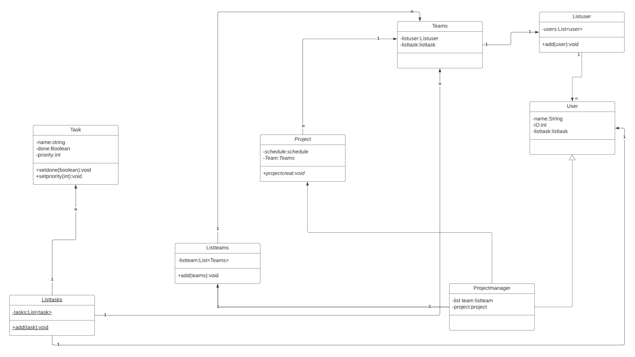

UI Prototype:

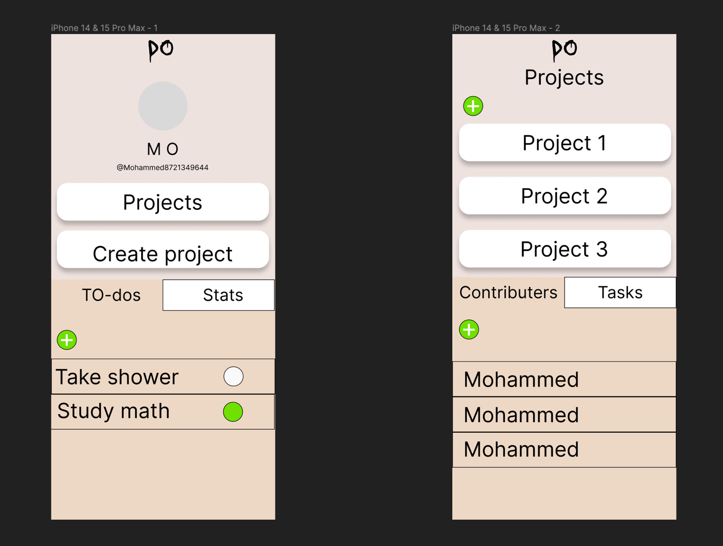Prototype of the home screen and the project screen

Reference and Definitions :

1 – Usability :

2 – Integrity

3 – Testability

4 – Reusability

5 – Maintainability

A quality requirements taxonomy, as defined in [Wiegers 2003].